Jaypee Institute of Information Technology, Noida.

Subject: Unix Programming Lab

LAB TEST-2

SET-A

1. Write command to to create a directory such that anyone in the group can create a file and access any person's file in it but none should be able to delete a file other than the one created by himself. [C373.5]

2. Write a script to print the sum of first 10 natural number. [C373.5]

3. Write a command to set a file file to be sticky, readable and writeable by the owner, readable by their primary group an inaccessible by everyone else. [C373.5]

4.)Create following directory structure [C373.5]

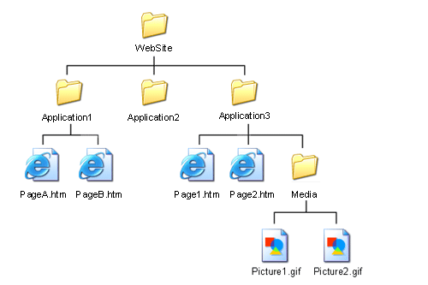

(a) If you are a root user, write a command to grand execute permission only for the owner of the file Page1.html?

(b ) Write a command to add execute permission for all users on file media.

(b) Remove write permission from directory media and application for user only.

(c) Move PageA.htm to directory Media